
April is National Financial Literacy Month
Resources Links to learn how to manage your money wisely, use credit and loans carefully,
and maintain financial security
https://www.consumer.gov https://www.mymoney.gov/

Thank you for picking up this flyer to learn more about financial literacy and to assist you in making well-informed decisions about your money. Below you will find online resources to learn more about managing your money, securing loans, credit scores, and general tips on making sound financial decisions. These resources cover each of the key components of financial literacy: earning, spending, saving & investing, borrowing and protecting.

Resources:
consumer.gov, MyMoney.gov, MilitaryConsumer.gov, ConsumerFinance.gov, ConsumerFTC.gov

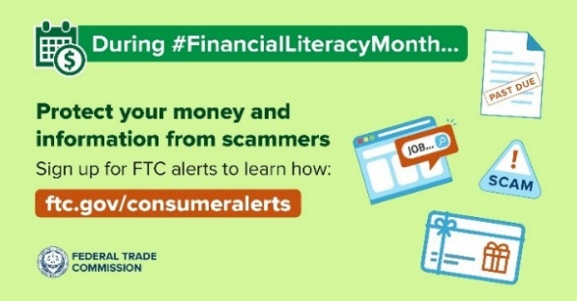
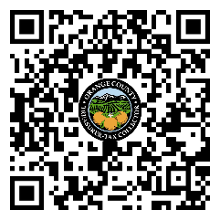
SAVING AND INVESTING
Buying a House
consumerfinance.gov/owning-a-home/
Making a Budget
consumer.gov/managing-your-money/making-budget
Retirement Planning
consumerfinance.gov/consumer-tools/retirement/
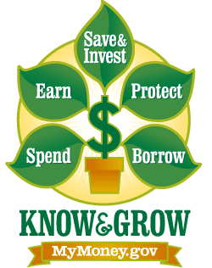
MANAGING YOUR MONEY

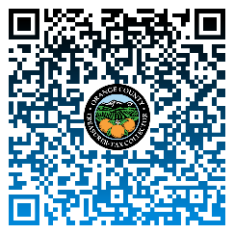
Saving Money When You Shop
consumer.gov./managing-your-money/saving-money-when-you-shop
Using Debit Cards
consumer.gov/managing-your-money/using-debit-cards

Opening a Bank Account
https://consumer.gov/your-money/opening-bank-account
Renting an Apartment or House
consumer.gov/managing-your-money/renting-apartment-or-house
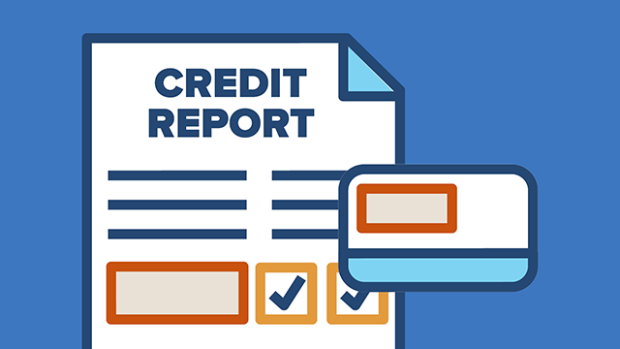
CREDIT, PERSONAL LOANS, & DEBT

Your Credit History
consumer.gov/credit-loans-debt/your-credit-history
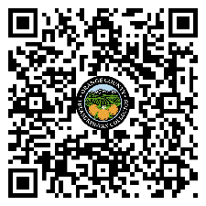
Payday Loans and Cash Advances
consumer.gov/credit-loans-debt/payday-loans-cash-advances
Home Equity and Lines of Credit
consumer.ftc.gov/articles/home-equity-loans-and-home-equity-lines-credit
Fixing Your Credit
consumer.ftc.gov/articles/fixing-your-credit-faqs
Check your credit report at least annually, find out how to get your free annual credit report at:
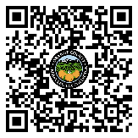
consumer.ftc.gov/articles/free-credit-reports or call 1-877-322-8228
Questions? 1-877-FTC-HELP or file a complaint at ReportFraud.ftc.gov

